**weInstall Papyrus modules from CD:**

1. The software comes in 2 cd’s. Please burn the 2 iso files to 2 cds: ISIS_Disc1.iso, ISIS_Disc2.iso
2. Load disk1 onto cdrom drive
3. From AutoPlay, select Run SET_W32.exe
4. Take ‘English’ as the language, click “>>” to continue
5. Uncheck ‘Hardlock key driver’
6. Take default for Source Path
7. Take default for ISIS_cd.id file
8. Take default for Target Path
9. Take default for ISIS_COMMON path
10. Leave ‘Product code’ empty and hit “>>” to continue
11. Under ‘Product Selection”, keep the <Ctrl> key depressed to make the multiple selection:
    1. Highlight ‘ISIS DESIGN PRODUCTS’ header, all the modules under it will be selected
    2. For ‘ISIS PAPYRUS CLIENT PRODUCTS’, pick the 1st 3 entries in that section
    3. For ISIS DOCUMENTATION, highlight the section header to select all
    4. For ISIS DOCUMENT SAMPLES, highlight the section header to select all
    5. For the ISIS Tools, highlight the section header to select all
12. The next screen will show all the items selected
13. Hit ‘Start’ to start the installation
14. Let the software create c:\ISIS folder
15. Insert cd2 when prompted

**Prepare the modules for usages**

1. Copy the fonts300 folder in the zip file to overwrite the same folder in c:\isis. Overwrite the files already existing in c:\ISIS when prompted.
2. From the zip file copy pddw3.prf, pdde.prf and DEFAULT.LBP to c:\isis\userisis to overwrite the same files there
3. Set up the following environment variables:
   1. ISIS_COMMON = C:\ISISCOMM
   2. ISIS_KEY_MODE = ALL
   3. ISIS_OMS_DOMAIN = 12.189.22.167, 10.8.9.72
   4. ISIS_OMS_PORT = 9091

**Build Font catalogs**

1. Start -> All Programs -> ISIS Products -> Overview AFP Designer
2. Options -> Libraries
   1. Click ‘Coded Font’ on the right
   2. Click ‘300 dpi’ at bottom
   3. Click ‘c:\isis\fonts300<FON>’ For the Path
   4. Click ‘Build Cat.’ to start building the font catalog. It will take a little bit of time. See below:

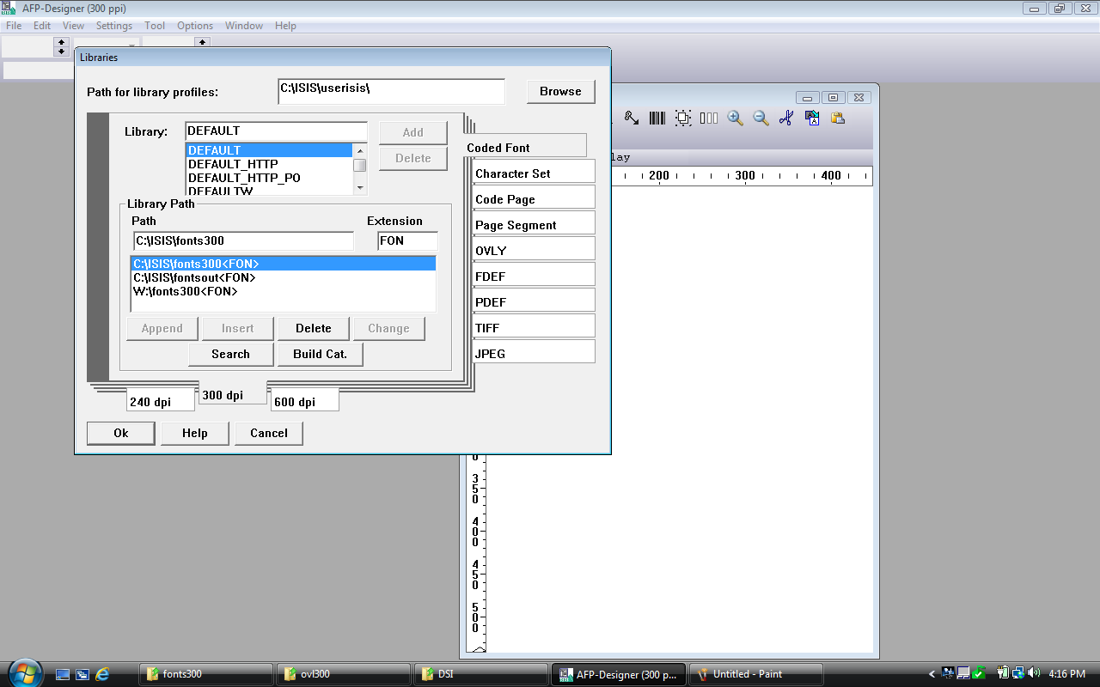

* 1. Click ‘Character Set’ on the right
  2. Click ‘300 dpi’ at bottom
  3. Click ‘c:\isis\fonts300<CHS>’ For the Path
  4. Click ‘Build Cat.’ to start building the font catalog. It will take a little bit of time. See below:

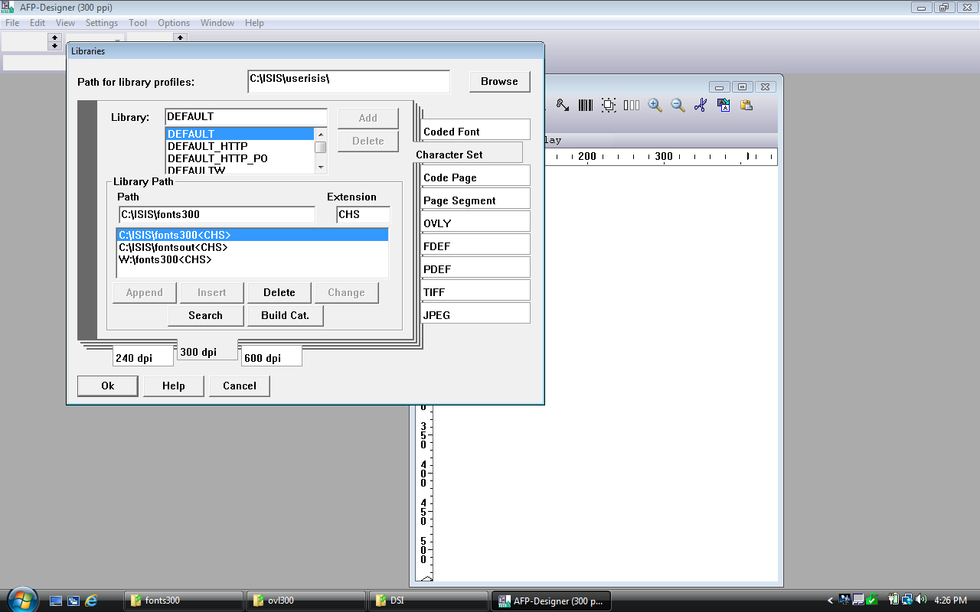

* 1. Click ‘Code Page’ on the right
  2. Click ‘240 dpi’ at bottom
  3. Click ‘c:\isis\fonts300<CDP>’ for the Path
  4. Click ‘Build Cat.’ to start building the font catalog. It will take a little bit of time. See below:

